Chest X-ray
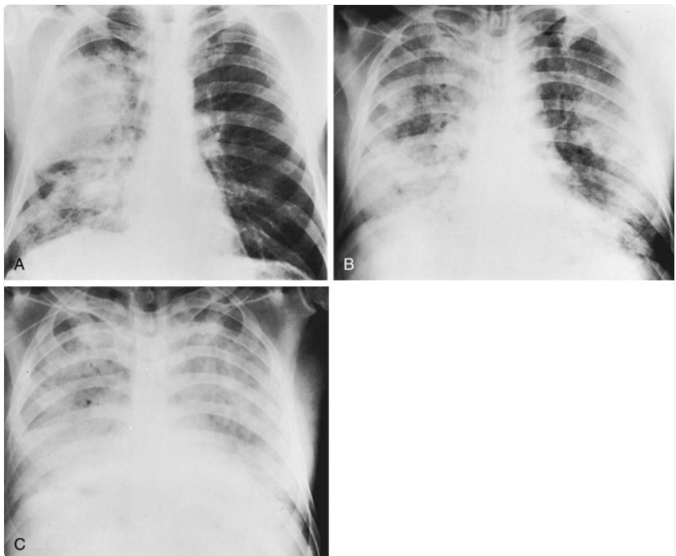
PATIENT INFORMATION:
- Age: 32 years
- Gender: Male

CLINICAL INDICATION:
Three days of cough with whitish-yellow sputum, pleuritic pain on the right side of the chest, and fever.

FINDINGS:
Posteroanterior chest radiograph shows extensive homogeneous air-space consolidation of the right upper lobe with focal air-space consolidation opacities of the right lower lobe. The left lung is unremarkable.

IMPRESSION:
Right upper lobe pneumonia with right lower lobe involvement.

